Aker BP Selects Aucotec to Drive Operational Efficiency in Yggdrasil

Press Release

January 30, 2025

* **Strategic Contract: Aker BP chooses Aucotec’s Engineering Base to implement Engineering Design Data Management (EDDM) for the Yggdrasil development project.**
* **Driving Innovation: Engineering Base delivers a ready-to-deploy platform for seamless, data-driven workflows.**
* **Future-Proof Operations: The collaboration enables true As-Built data models and digital twins, like Aker BP’s Cognite Data Fusion, for safer, more efficient offshore operations.**

Aker BP, a leader in Norway’s oil and gas sector, has selected Aucotec as one of its’ partners in the digital infrastructure of the Yggdrasil development. At the core of this decision is Engineering Base, a proven cooperation platform that helps to enhance operational efficiency and accelerates modification processes. Engineering Base has out-of-the-box capabilities to meet the demands of large-scale, complex projects like Yggdrasil with minimal customization.

**Engineering Base: Key part of Yggdrasil digital infrastructure**

Located in the Norwegian North Sea, Yggdrasil is the largest ongoing oil and gas development in Norway. The Yggdrasil area will play an important part of Aker BP’s future production from 2027. Given the project’s scale and complexity, seamless collaboration across teams and contractors is essential—a challenge met by Engineering Base.

By consolidating and validating vast amounts of engineering and Life Cycle Information (LCI) data, Engineering Base ensures that all stakeholders work from a unified, reliable data foundation. This data foundation also enables numerous AI-powered downstream processes on the platform. The platform delivers:

• Efficiency: Automated data integration accelerates workflows and minimizes errors.

• Safety: Real-time data enhances operational security and streamlines maintenance.

• Data quality: Workflow automation reduces manual effort, and improve quality of data.

With comprehensive Change Management capabilities Engineering Base allows modifications to be seamlessly integrated into the As-Built model, ensuring data integrity throughout Yggdrasil’s lifecycle.

**Shaping the future of digital operations**

“With Yggdrasil, Aker BP is setting a new standard through remote operations, periodically unmanned and unmanned installations, low activity set offshore and new technology. Availability of data is an important basis for this operations strategy. EDDM will serve as a foundational solution supporting both Life Cycle Information (LCI) and engineering data, thus driving operational excellence in Yggdrasil. Aucotec and its ready-to-deploy functionality in Engineering Base empowers us to centralize and optimize engineering data immediately,” says Lars-Erik Ydstie, Vice President Digital Yggdrasil at Aker BP.

Uwe Vogt, Member of the Executive Board at Aucotec, adds: “We are proud to support Aker BP in this groundbreaking project. Engineering Base demonstrates how proven, data-driven solutions can transform the energy and process industries.”

**Images* and captions:**

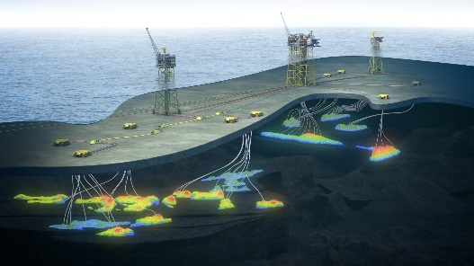

[Yggdrasil](https://www.aucotec.com/fileadmin/user_upload/Company/Pressemitteilung/2025/1_2025/AUC_AKerBP_Yggdrasil_from_Munin.jpg) is the largest ongoing oil and gas development in Norway. (Image: Aker BP)



Seamless collaboration across teams and contractors is essential in the [Yggdrasil project](https://www.aucotec.com/fileadmin/user_upload/Company/Pressemitteilung/2025/1_2025/AUC_AKerBP_Yggdrasil_total_scope.jpg)—a challenge met by Engineering Base from Aucotec. (Image: Aker BP)

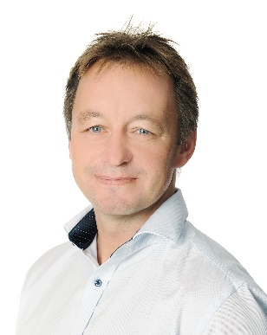

[Lars-Erik Ydstie](https://www.aucotec.com/fileadmin/user_upload/Company/Pressemitteilung/2025/1_2025/AkerBP_Lars-Erik_Ydstie.jpg), Vice President Digital Yggdrasil at Aker BP. (Image: Aker BP)



[Uwe Vogt](https://www.aucotec.com/fileadmin/user_upload/Company/Pressemitteilung/2025/1_2025/AUC_Uwe_Vogt.jpg), member of the Aucotec Management Board (Image: AUCOTEC AG)

*These images are protected by copyright. Editorial use free of charge is permitted in connection with this press release. All photographs are otherwise subject to the terms and conditions of their respective owners.

*These images are protected by copyright. They may be used for editorial purposes in connection with Aucotec.

___________________________________________________________________________

[AUCOTEC AG](https://www.aucotec.com/en/) has almost 40 years' experience in the development of engineering software designed for use throughout the life cycle of machinery, plant equipment and mobile systems. Solutions range from flow diagrams and process-control/electrical technology for large-scale plant systems to modular on-board power supply units designed for the automotive industry. Software supplied by Aucotec is currently in operation throughout the world. In addition to the headquarters near Hanover, the Aucotec Group includes six other locations in Germany as well as subsidiaries in China, India, Malaysia, South Korea, the Netherlands, France, Italy, Austria, Poland, Sweden, Norway and the USA. What is more, a global partner network ensures local support all over the world.

We would be grateful if you could supply us with a copy of your article. Thank you very much!

**Contact:** 

**AUCOTEC AG**, Hannoversche Straße 105, 30916 Isernhagen, www.aucotec.com

Public Relations, Arne Peters ([arne.peters@aucotec.com](mailto:arne.peters@aucotec.com) +49(0)511-6103192)